GAS CAP BITS CONFUSION:

1: GAS CAP UPSIDE DOWN, CONICAL "NOSE"
AND BIT AND GASKET

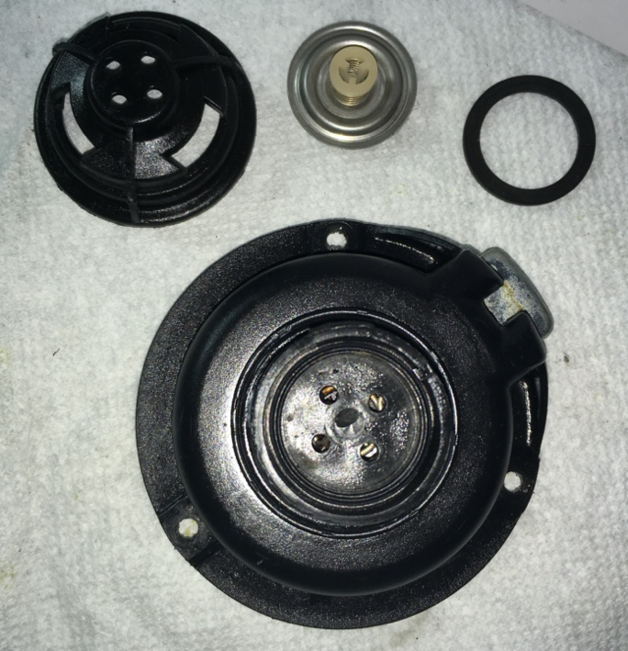

2. BIT IN ONE WAY:

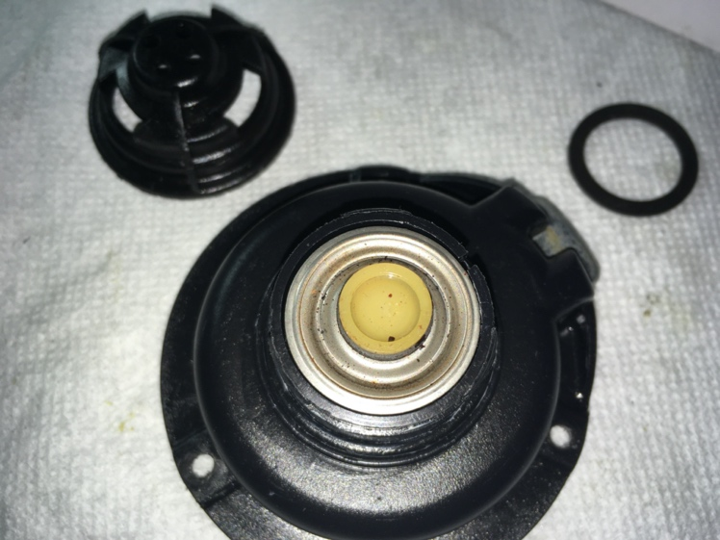

3. BIT IN OTHER WAY

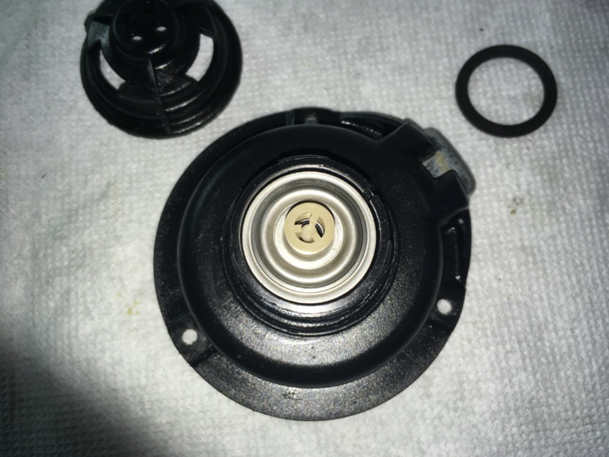

WHERE DOES GASKET GO: UNDERNEATH BIT OR
ON TOP?

